

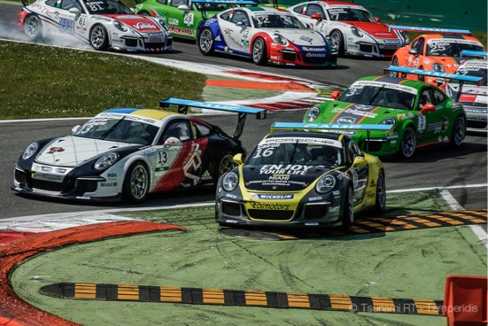
CENTRO PORSCHE PADOVA

Press Release #08.2016 2/5/2016

Porsche Carrera Cup Italia, Round 1, Monza 29/4-1/5

Two podiums in three races - what a weekend!
This was a tough weekend in Monza for Tsunami RT - Centro Porsche Padova: after three races with 4 drivers in two cars the team was rewarded with two podium finishes and with loads of experience for the next PCCI races!

Qualifying 1 & 2
#13 Côme Ledogar was 2nd fastest in Q1 (1'51"824) and secured the first row on the grid of race 1 behind pole setter #16 Matteo Cairoli (1’50”663). #33 Matteo Torta, who had limited time in free practice, struggled in qualifying and made it only to 16th on the grid of race 1 with 1’55”744.
In Q2, #33 Mikael Grenier was 6th fastest and reserved a place in the 3rd row on the grid of race 2. The Canadian found the right balance and despite he had setup issues in FP1, he snatched a real good 1’52"083. #13 Alex Gaidai couldn't understand what really went wrong in his qualifying run and he was not satisfied with his fastest lap - 1'53"690 - that gave the Ukrainian the 13th position on the grid of race 2. #16 Matteo Cairoli #16 snatched the pole position for race 2 as well with 1’50”761.

Race 1
Tsunami star #13 Côme Ledogar finished 2nd with a 14” gap from Matteo Cairoli, who will not follow the whole Carrera Cup Italia in 2016. There was a bit of dramma in the first “variante” right after the start between the two when their cars collided and the Italian cut the chicane to take the lead and dominate the race till the end. The second Tsunami RT car, #33 driven by Matteo Torta, finished in 12th position.

Race 1 Classification
1. Matteo Cairoli 15 laps in 28'04"982 (185,7 km/h); 2. Come Ledogar +14”281; 3. Eric Scalvini +33”903; 4. Alessio Rovera +38”907; 5. Enrico Fulgenzi +43”177; 6. Marco Cassarà +46”745; … 12. Matteo Torta +1’14”108;

Race 2
An exciting race and pretty rewarding for Tsunami RT - Centro Porsche Padova. #33 Mikael Grenier after some exiting fights with Drudi, Rovera and Giovesi, took a deserved 3rd place and happily stood on the iconic podium of Monza. A remarkable result for the young Canadian who makes his comeback in professional racing with Tsunami after a three years break!
#13 Alex Gaidai did a good start to climb on 10th in the first lap from 13th on the grid and after some good fights with De Giacomi and thanks to the accident at the front, he took the flag in 7th position. Alex had a strong pace throughout the race. Matteo Cairoli dominated the second sprint race keeping an identical pace as in the first one.

Race 2 Classification
1. Matteo Cairoli 15 laps in 28'03"756 (185,8 km/h); 2. Mattia Drudi +27”767; 3. Mickael Grenier +29”202; 4. Eric Scalvini +30”678; 5. Alessio Rovera +31”866; 6. Daniele Di Amato +37”601; 7. Oleksandr Gaidai +37”961;

Race 3
This third Carrera Cup Italia race started after two laps behind the safety car because of an insisting spring rainfall that ended only minutes before the Porsche Carrera Cup Italia competitors were aligned on the grid. The race was declared wet and finished with a positive result for Tsunami RT - Centro Porsche Padova despite the ever changing conditions of the track.
The duo #13 Alex Gaidai/Côme Ledogar took the flag in 5th position while the #33 car with Mikael Grenier/Matteo Torta finished 9th overall among the 14 cars who completed the 45' race. At the finish the track was semi-dry with patches of water around the corners.
The pit stops where executed perfectly, while other teams committed mistakes. In the #13 car, Gaidai took the start on rain Michelin and Ledogar finished the race on slicks. In the #33 car, Grenier started always on rain tyres and handed the car to Torta who continued with a rain set. Thumbs up for the work of the team on the pit lane!

Race 2 Classification
1. Matteo Cairoli 22 laps in 47’11”120 (162,1 km/h); 2. Mattia Drudi +34”834; 3. Alessio Rovera +39”080; 4. Daniele Di Amato +48”453; 5. Oleksandr Gaidai – Come Ledogar +49”807; 6. Eric Scalvini +1’25”046; 7. +1’56”593; 8. Marco Cassarà +1 lap; 9. Mikael Grenier – Matteo Torta +1 lap; 10. Hans Peter Koller +1 lap

PCCI 2016 Classifications
After the first PCCI 2016 weekend in Monza #16 Matteo Cairoli leads the classification but the Italian will not follow the entire championship. In the drivers’ classification Tsunami RT star Côme Ledogar stands 4th, Alex Gaidai 7th, Mikael Grenier 8th and Matteo Torta 11th. In the teams classification Tsunami RT - Centro Porsche Padova stands 3rd. The second round the Carrera Cup Italia 2016 series is at Imola in the last weekend of May (27-29/5). See the detailed classifications on the following link:
http://www.carreracupitalia.it/ita/stagione-classifiche

Tsunami RT - CPP drivers’ quotes:

#13 Alex Gaidai
[race 2]: “I had an opportunity to get a little higher but I had to keep a perfect balance between speed and keeping the car safe for the third race. The car is completely all right and good. Anyway, the low yesterday’s mood has gone and I hope it won’t get back. I am very happy with Mikael: he has shown a very good pace today!”

[race 3]: "Of course, we wanted to be on the podium today but this is the first race in the new format, and it was very important for us to avoid any mistakes. The result is not bad, the car is all right, the team worked well and we had one of the fastest pit stops - so everything is well”

#13 Côme Ledogar
[race 1]: “The start was quite good and in the first corner I was a little ahead of Cairoli. Well, I was sure that he wouldn’t take a risk to spoil the first race of the season, I thought that he would prefer the clean fight. But he hit my car and then cut the chicane to create a gap. Well, that’s it – we have finished in that order. Of course, any racing driver can’t be satisfied when he doesn’t win – so I’m not satisfied now”

[race 3]: “The race was good fun. We had a very good first sting with Alex on rain tyres and we had a really good strategy - we changed to dry tyres and I am happy with the driver change, it was perfect. Let’s go for a podium next time because we have the potential”.

#33 Mikael Grenier
[race 2]: “An incredible race! I did a bad start and slipped back to P8 but the car was really good, it helped me a lot, so I said to myself 'keep calm' and I started to attack. I had to be smart: I didn’t want to crash with somebody and there was a lot of traffic during the whole race. I’m very pleased with the result of my first race - after three years away from racing! The team did a really fantastic job - the car was great!”

[race 3]: “An interesting race with these conditions, wet but got dry fast. I thought we had still one more lap behind the SC (Parabolica was yellow flagged) so I was far back at the start but soon gained positions up to 6th. I was pleased with that and I enjoyed the race, trying to find dry parts on the track”

#33 Matteo Torta
[race 3]: “It was a good race, our first long one with driver change and we avoided mistakes others did. The car was really good despite the conditions. In the end it was dry and it was hard for me to not make a mistake on rain tyres. I was afraid I would burn them”.

Copyright free images from Monza weekend:
https://www.dropbox.com/sh/dutuyi4hm6fgp8a/AACz1TwqvpwWFv-OnmYgewKva?dl=0
Officlal Tsunami RT - CPP website:
http://tsunami-rt.com/en/
Media requests:
media@tsunami-rt.com
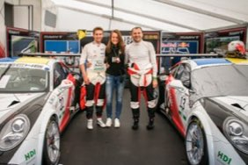
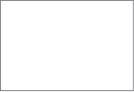
Download link: https://www.dropbox.com/s/f559rwulkxwvehw/DSC01211.jpg?dl=0

