

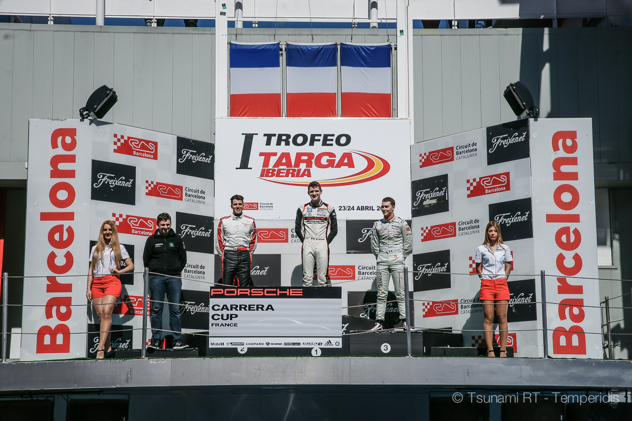
CENTRO PORSCHE PADOVA

Press Release #06.2016 25/4/2016

Porsche Carrera Cup France, Round 1, Barcelona 22-24/4

Deserved podium finishes for Jouannem & Gaidai
After a disappointing Saturday race, Sunday was a success story for the Tsunami RT drivers: Jouannem made it to 2nd on the podium and Gaidai to 3rd among gentlemen. Definitely a bitter-turned-sweet weekend in Barcelona…
The racing weekend in Barcelona was crucial for Tsunami RT - Centro Porsche Padova for more reasons: it was not only the first of the 2016 French Carrera Cup, not only the first ever Carrera race for young Alex Jouannem but it was also the first for the Ukrainian team with three cars in the box. The third one was prepared for Spanish gentleman driver Daniel Diaz Varela.
It is like history in the making, as Tsunami is in dramatic transformation in the last few years: from a small team of privateers with one or maximum two cars, it expands to a professional “equipe” of 3-4 cars this year in the Italian and French PCC races. The Catalunya race was a real test event of organisation, logistics, human resources and stamina.
In the Saturday qualifying, young gun Alex Jouannem did it to fifth on the grid of the very first race for 2016 PCCF, lapping at 1'51"248, while poleman Matteo Cairoli did 1’50"150. The tall 21-year old French was 3rd fastest in the qualifying for the 2nd race pulling out 1’50”765, while poleman Jaminet and Cairoli where the only two who lapped in 1’49”.
Alex Gaidai was only P10 on the grid (P2 for car. B) of the first race and P12 for the second, paying the price of the missed Free Practice for engine error signals the previous day. Daniel Diaz Varela improved impressively from Friday and took a P14 for the first race and P11 for the second, lapping 1/1000 sec faster than Gaidai in Q2.

Race 1
The 1st race of the French Carrera Cup 2016 was definitely forgettable for Tsunami RT - Centro Porsche Padova. Alex Gaidai - who started pretty well gaining 2-3 positions towards the first corner - was implicated in an unavoidable accident in the second corner with Rivas. The Ukrainian finished in the gravel with his Porsche severely damaged on the right side and managed to re-enter the track having lost 3 laps from the rest of the field. Alex Jouannem had a complicated start and lost three positions while trying to avoid the same accident in which Gaidai was involved. Later in the race Alex had an exit that pushed him back to the field. The talented French finished the race only 12th and he was pretty disappointed after the finish. The only Tsunami driver who felt good after the finish was Daniel Diaz Varela: the big Spanish man did a decent race to 11th overall - P4 in the gentlemen class. Race results was not the best way to celebrate Irina Kolomeitseva’s birthday but the team had a nice party in the huge box early in the evening, after Gaidai’s 991 looked fit to race.
Click here for full Race 1 results:
http://circuitcat.com/documentos/carreras/PORSCHECARRERACUP_RACE1_BOOKLET.pdf

Race 2
The Sunday race proved to be less dramatic for the Tsunami drivers but far more rewarding. Jouannem started good from 3rd and overtook Matheu Jaminet on the first corner while Cairoli was 1st. But the Italian had gearbox problems right after, so from the trio Jaminet and Jouannem were left leading the field. The Tsunami RT - Centro Porsche Padova driver could manage the pack of 4 drivers who were following but couldn’t keep Jaminet’s pace. Alex Jouannem settled in 2nd with 9,372” gap in his second Carrera Cup race, after a long break from racing. A remarkable success for the team and a great boost for the morale of the French driver.
On the other side, Gaidai did a consistent and strong race up to 9th overall and 3rd in the gentlemen class, behind Lindland and Lapierre - his usual competitors in the French PCC for the last years. Varela was unlucky in the race, as he had to retire after he spun and ended in the gravel.
Click here for full Race 2 results:
http://circuitcat.com/documentos/carreras/PORSCHECARRERACUP_RACE2_BOOKLET.pdf

Drivers quotes
Alex Jouannem (#47): “I did a strong start and for a moment I was even leading the race but I lost my position from Jaminet. In the following laps, I cared about keeping a safe distance from the second group. Towards the end of the race I could raise my pace. I managed the race very well, it was completely different than the first one, where I could manage almost nothing. Today everything was right!”
Alex Gaidai (#13): “This is the first podium of 2016 but I still want more. Yesterday’s collision had an influence on today’s start pretty much because I tried to stay away from trouble. Overall my race was not bad but unconsciously I drove with my mind to next weekend’s race in Italy. We both did it on podium but it would be much better to win. And we will do it!”
Daniel Diaz Varela (#36): “Today I didn’t enjoy the race too much because I did a mistake and finished in the gravel. But I enjoyed the weekend thanks to Tsunami - a great team actually! In these few days I learnt far more things than in a whole season with my previous team. I am very happy!

Copyright free images
https://www.dropbox.com/sh/qd06tk99kygbze1/AAAHtkW9fo9YU1Lg-0B1a-cka?dl=0
Officlal Tsunami RT - CPP website:
http://tsunami-rt.com/en/
Media requests:
media@tsunami-rt.com
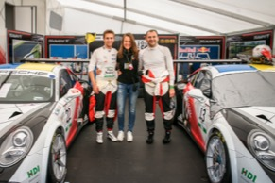

Download link: https://www.dropbox.com/s/f559rwulkxwvehw/DSC01211.jpg?dl=0

