


Press Release #03.2016 21/3/2016

Hankook 12hours Italy-Mugello Race

Tsunami 2nd in its class after a sensational comeback!
The Ukrainian team had a setback in the first two hours but came back strong to clinch the 2nd place in the 991 class and 11th overall in the Italian endurance race.
The 12 hour race of Mugello was included in the 2016 calendar of the 24 Hour International Endurance Series among the 24-hour races of Dubai, Silverstone, Paul Ricard and Barcelona and the 12-hour races of Zandvoort and Brno.
The Italian round of the Dutch-organised series proved to be a big motorsport fiesta and was run in two different days during last weekend: the first 4 hours were run on Friday afternoon and 8 hours on Saturday.
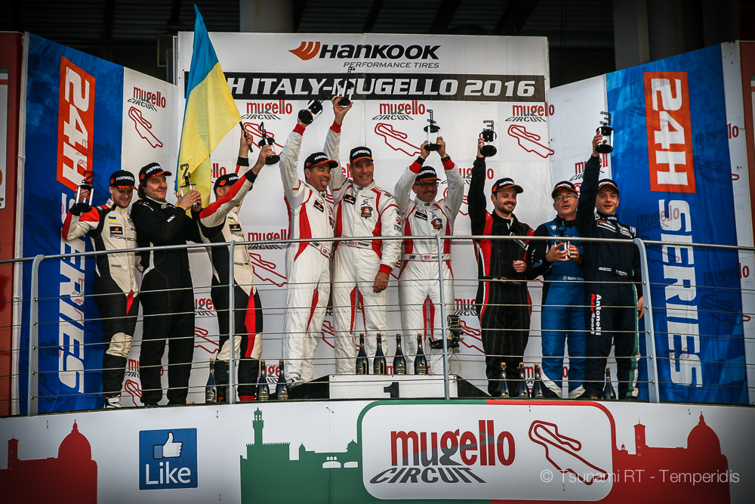
Tsunami RT entered the race with three drivers at the wheel of its Porsche 991 Cup: Côme Ledogar and Alex Gaidai, the duo that will represent the Ukrainian team in the 2016 Carrera Cup Italia, accompanied by the Ferrari Challenge driver from Greece, Kriton Lentoudis. The car was equipped with ABS and fitted with a restrictor exclusively for the race.
In qualifying, Ledogar undertook the job to chase a class pole. After the 45’ session he was 2nd fastest in the 991 class with 1’54”083 and the Tsunami Porsche was placed 19th on the grid. The 24-year old Frenchman, since he is the fastest driver of the trio, was appointed to start the race. Côme was focused to create a good margin for his teammates.
But things went wrong in the first hour when the driver entered for his first refueling: the organiser’s petrol pumps (their use is obligatory for all teams according to the race regulation) were all blocked and the refuelling turned to disaster. Only 10 litres were refuelling and the team had lost precious time - almost 4 laps from its competitors - given that Ledogar had to pit again for refuelling. Bad luck didn’t stop there. During his two-hour stint, the Frenchman had a punctured tyre. As a result, he lost more time and trailed further back in the classification, despite his superb lap times on track.
Alex Gaidai took the wheel and did a very strong stint that was again setback by a destroyed tyre on the fast “Arrabbiata” corner. Cold blood and great car control was needed in order to return safely to the pit. The Ukrainian handled the Porsche to Kriton Lentoudis to complete the first leg of the race from 9th position in 991 class. The Greek gentleman was a little bit slower but very consistent and climbed to 8th in class and 31st overall till the end of the day.
Day two started with young gun Côme Ledogar taking the wheel first at the grid, where all the cars had stayed overnight. He was impressive in his two-hour stint bringing back the car in 5th position in its class and 19th overall! Pit stops worked great, even better than in the first day with the Tsunami mechanics performing a complete tyre change in less than 30”!
Alex Gaidai did the second stint, followed by Ledogar again and Kriton Lentoudis did the 4th stint. In the 7th hour, the Tsunami RT Porsche was 4th in its class and in the 8th hour in 3rd position but 4 laps behind the first two 991. The last four hours of the race rolled smoothly and Alex Gaidai undertook the last stint to take the chequered flag.
The Tsunami Porsche had secured the P3 on the class podium but one hour before the finish, the #56 Dinamic team Porsche, that was 2nd in class at the moment, was shockingly involved in a freak accident with Giovanni Berton at the wheel. The Italian crashed on the #14 Audi R8 - that was standing still on the racing line – at 200 kmh but thankfully none of the drivers was hurt!
This accident – that should have been avoided - upgraded the Tsunami RT to 2nd on the 991 class podium behind the MRS-GT Racing Porsche from USA that took a deserved win. The Tsunami RT Porsche completed 331 laps in 12 hours, a result that demonstrates the speed and consistency of the drivers as the efficiency of the team in the pit stops. Thanks to the 12-hour race Tsunami RT is a far better and more experienced team than before!

Tsunami RT drivers quotes
Alex Gaidai: “I would like thank all the members of our team for the fantastic job, for their effort and dedication, for the energy at the box and during the pit stops. We were unlucky the first day but we found the way to bring back a very good result”.
Côme Ledogar: “I really drove very fast during my stints and my teammates were also very good. Alex was strong as always and Kriton, proved to be a gentleman that I would love to race together in the future. The pit stops worked well and if we resolve certain organisational and setup problems, we can be really strong in the future”
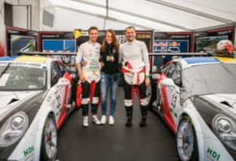
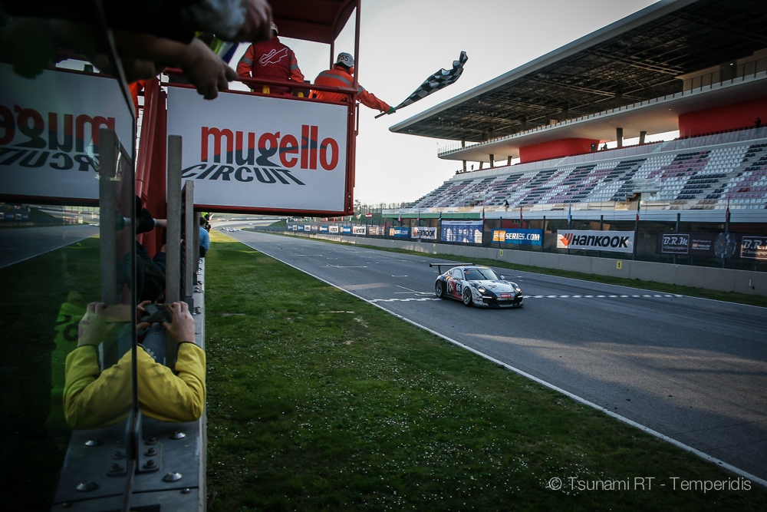
Kriton Lentoudis: “The team worked really good and I enjoyed the experience with them despite we had some problems in the first day. I may not have driven as much as Côme and Alex but I am happy with myself and my performance and really proud for the podium finish”.
Tsunami RT photos
https://www.dropbox.com/sh/b5gtuse7qaky8d4/AACNKhwntffM20M9LV2v9nGBa?dl=0
Final results
http://www.raceresults.nu/uitslagen//2016/24H%20Series/Hankook%2012H%20ITALY-MUGELLO%202016/12H%20-%20Race%20(part%202).pdf
Final results per class
http://www.raceresults.nu/uitslagen//2016/24H%20Series/Hankook%2012H%20ITALY-MUGELLO%202016/12H%20-%20Race%20(part%202)%20-%20per%20class.pdf
Official Tsunami RT website:
http://tsunami-rt.com/en/
Media requests:
media@tsunami-rt.com

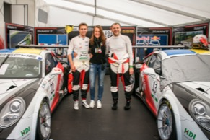
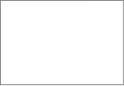
Download link: https://www.dropbox.com/s/f559rwulkxwvehw/DSC01211.jpg?dl=0

